C  
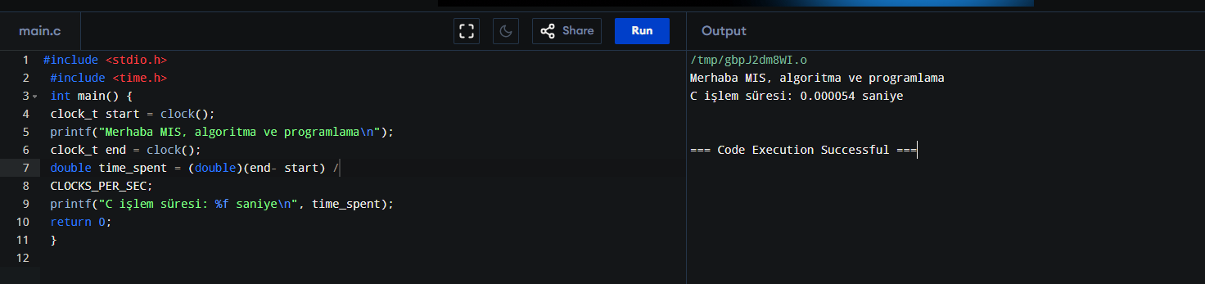  
  
C++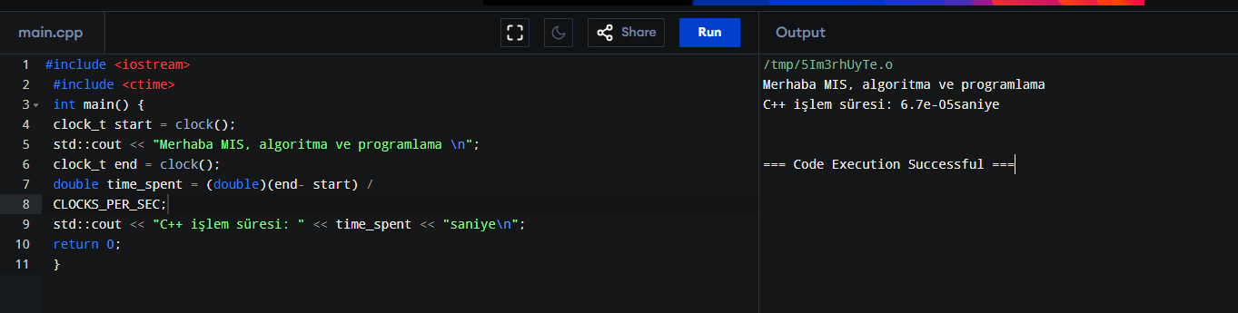  
  
C#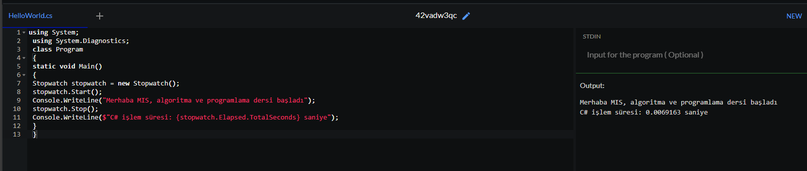  
  
Java  
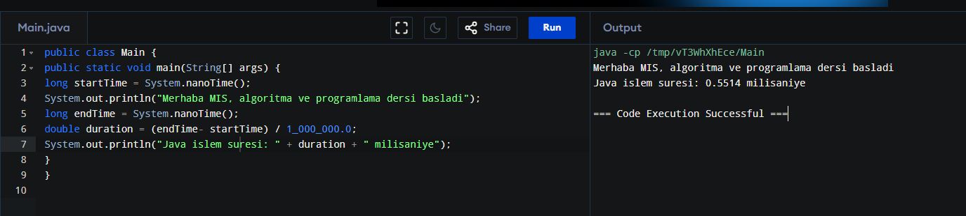

NodeJS

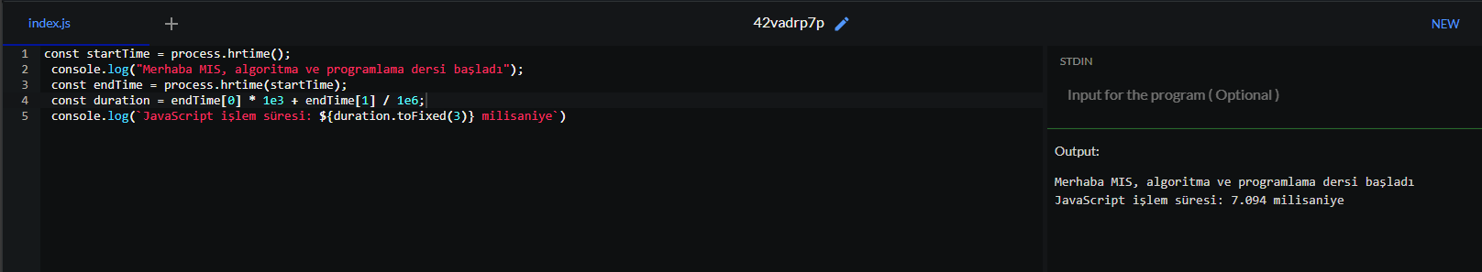

GO

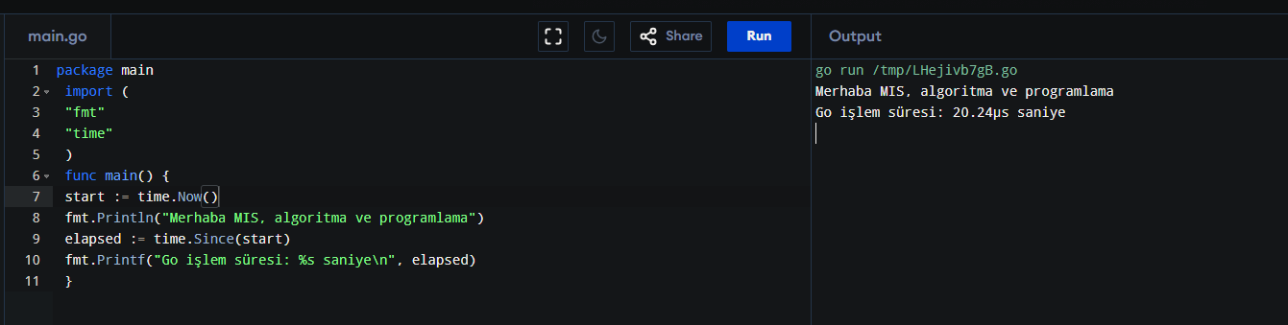

Rust

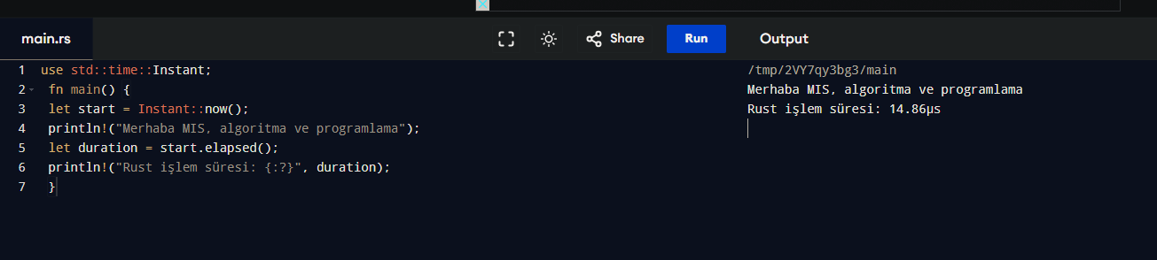

Ruby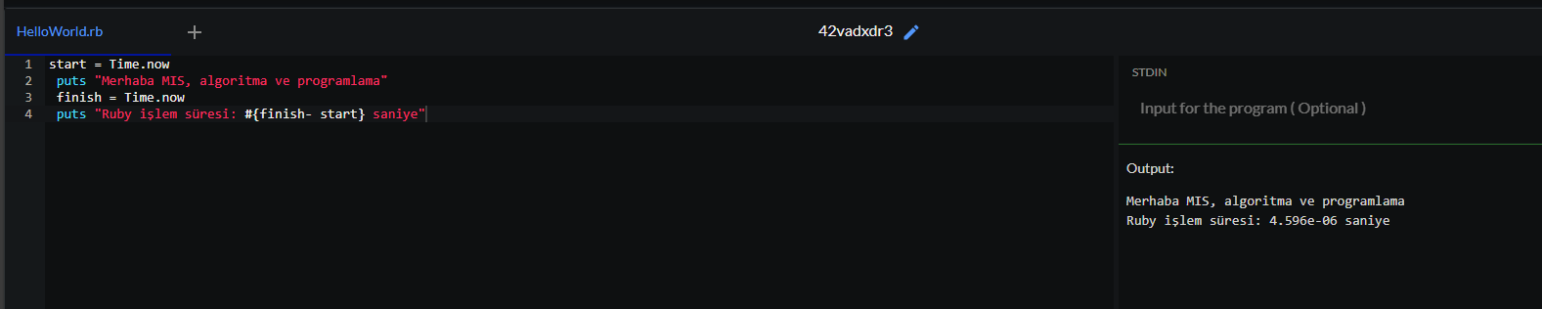

Perl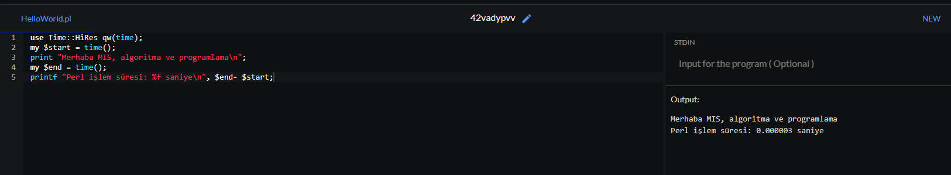

Python

